REVISION HISTORY
REV | ECO
SW Programming Requirements (SPR)
CONTRACT NO. |  |  |  |  |  |  | Elbit Systems Ltd
ACTN |  | NAME |  | SIGNATURE | DATE | Advanced Technology Center
 |  |  |  |  |  | P.O.B. 539, Haifa 31053, Israel
PREP |  | T.B.D |  |  | 4/2018 | Title :
SEPG Manager |  | T.B.D |  |  |  | SW Programming Requirements (PR)
SW Manager
SQA |  |  |  |  |  | SIZE |  | CAGE CODE |  | NO.
 |  |  |  |  |  | A |  | 2288A
 |  |  |  |  |  | SCALE NONE |  |  |  |  |  |  | SHEET 1 of 12

THIS DOCUMENT AND ITS CONTENT BELONGS TO ELBIT SYSTEMS LTD. AND CONTAINS ELBIT PROPRIETARY INFORMATION.
THIS DOCUMENT AND THE INFORMATION CONTAINED IN IT OR ANY PART THEREOF MAY NOT BE COPIED IN ANY WAY AND MAY NOT BE USED IN WHOLE OR PARTS THEREOF IN ANY WAY WITHOUT THE WRITTEN CONSENT OF ELBIT SYSTEMS LTD.
© 2015 by Elbit Systems Ltd.

SW Programming Requirements

for the

DLS Project
BSP (Board support package)

CDRL SEQUENCE NO. T.B.D

Prepared for:
ELBIT SYSTEMS LTD.

Prepared by:
COMM-IT, 20 Hamagshimim St.
Petach Tikva 49348, ISRAEL

TABLE OF CONTENTS

1. Scope 4
2. Programming files Table 4
3. Programming Equipment and Set-Up 4
4. Programming Instruction 5
4.1. Burn full android (Program the target with images): 5
4.1.1. Program all system files to target device 5
4.1.2. Manually burn u-boot and SPL: 5
5. Appendixes 6
5.1. APPENDIX A – Start VM ghost OS on host PC 6
5.1.1. Open ghost on the host PC 6
5.1.2. Import the station (ghost) file and starting it 6
5.1.3. Login into the system 7
5.2. APPENDIX B: Enable “USB debugging” at Android target device 8
5.3. APPENDIX C: Check if the target is rooted and connected well 8

Scope
This SW PR describes the necessary files, means and procedures required to program the DLS system with the BSP package.

Programming files Table

TABLE I.  LOADING SEQUENCE |  |  |  |  | TABLE II.  VDD REFERENCE
NOTE: The SEQ No. is the order of loading the programs!
SEQ | Programming Tool | FILE NAME | CHECKSUM |  | VDD Number
1 | Android debug bridge (ADB) | boot-imx6q-var-dart.img | N/A |  | T.B.D
2 | Android debug bridge (ADB) | recovery-imx6q-var-dart.img | N/A |  | T.B.D
3 | Android debug bridge (ADB) | system.img | N/A |  | T.B.D

Programming Equipment and Set-Up

In order to program the APK (Android application package) to the system target you need to use Android data cable (Micro USB cable).
Then you must to install the followings:
- ADB tool at your host system (Explanation of tool installation provided at appendix A).
- Enable “USB debugging” at your Android target (The Android target must be rooted in order for programing the device).

Programming Instruction

Before programing the device please check that you accomplish appendix A + B + C and the target device in connected and configured well.

Burn full android (Program the target with images):

All files are can be located at relative path: /var_m_601_210/m_601_210_build/out/target/product

Program all system files to target device
1. Insert target to boot load state:
adb reboot bootloader (Insert the target to boot load state)

2. Program system boot load image:
sudo fastboot flash boot out/target/product/var_mx6/boot-imx6q-var-dart.img

3. Program Recovery system image:
sudo fastboot flash recovery out/target/product/var_mx6/recovery-imx6q-var-dart.img

4. Program System image (kernel + modules files)
sudo fastboot flash system out/target/product/var_mx6/system.img

5. Reset the device to take affects:
sudo fastboot reboot

Manually burn u-boot and SPL:
dd if=u-boot-var-imx6-mmc.img of=/dev/mmcblk2 bs=1k seek=69; sync
dd if=SPL of=/dev/mmcblk2 bs=1k seek=1; sync

Appendixes

APPENDIX A – Start VM ghost OS on host PC
The following Appendix will be describe how to load and start the virtual machine OS on the window PC host station:

Open ghost on the host PC
In order to run the virtual machine operation system you have to install the application: “Oracle VM VirtualBox manager” on windows PC (you can find it on the web at: https://www.virtualbox.org/ , this instructions set test on version: 5.1.26 of this software).

1. Import the station (ghost) file and starting it:

Import the station (ghost) file and starting it
On “Machine” tab -> click “add”. Then select the DLS.vbox file.
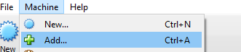

Please check that all of the settings of the machine are same as the following
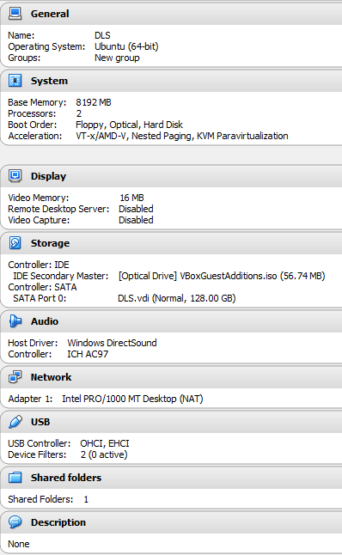

Then to start the machine click the green button “Start”

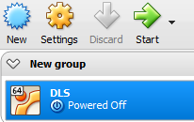

Login into the system

At the login part please insert the password “dls” for login into the system.

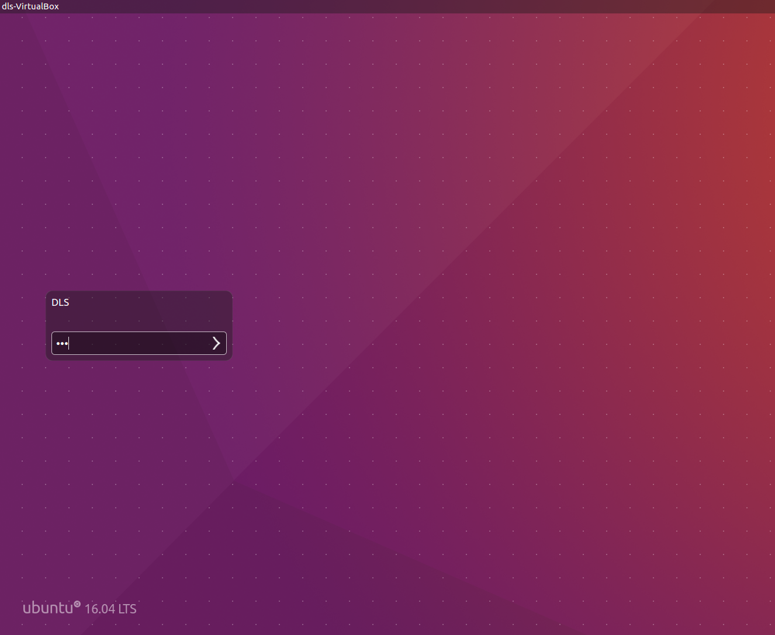

APPENDIX B: Enable “USB debugging” at Android target device

In order to work with ADB shell at the Android target the device you must enable the USB debugging options via the following procedure:
- Go to “System Settings”.
- Go to “Developer options”.
- Check the “USB debugging” options.

APPENDIX C: Check if the target is rooted and connected well

In order to check if the device is ready to program with ADB tool, you can insert the command “adb devices”
(both at Windows / Linux Ubuntu station) In case that the devices has no connection of configurations difficulties the following will present:

